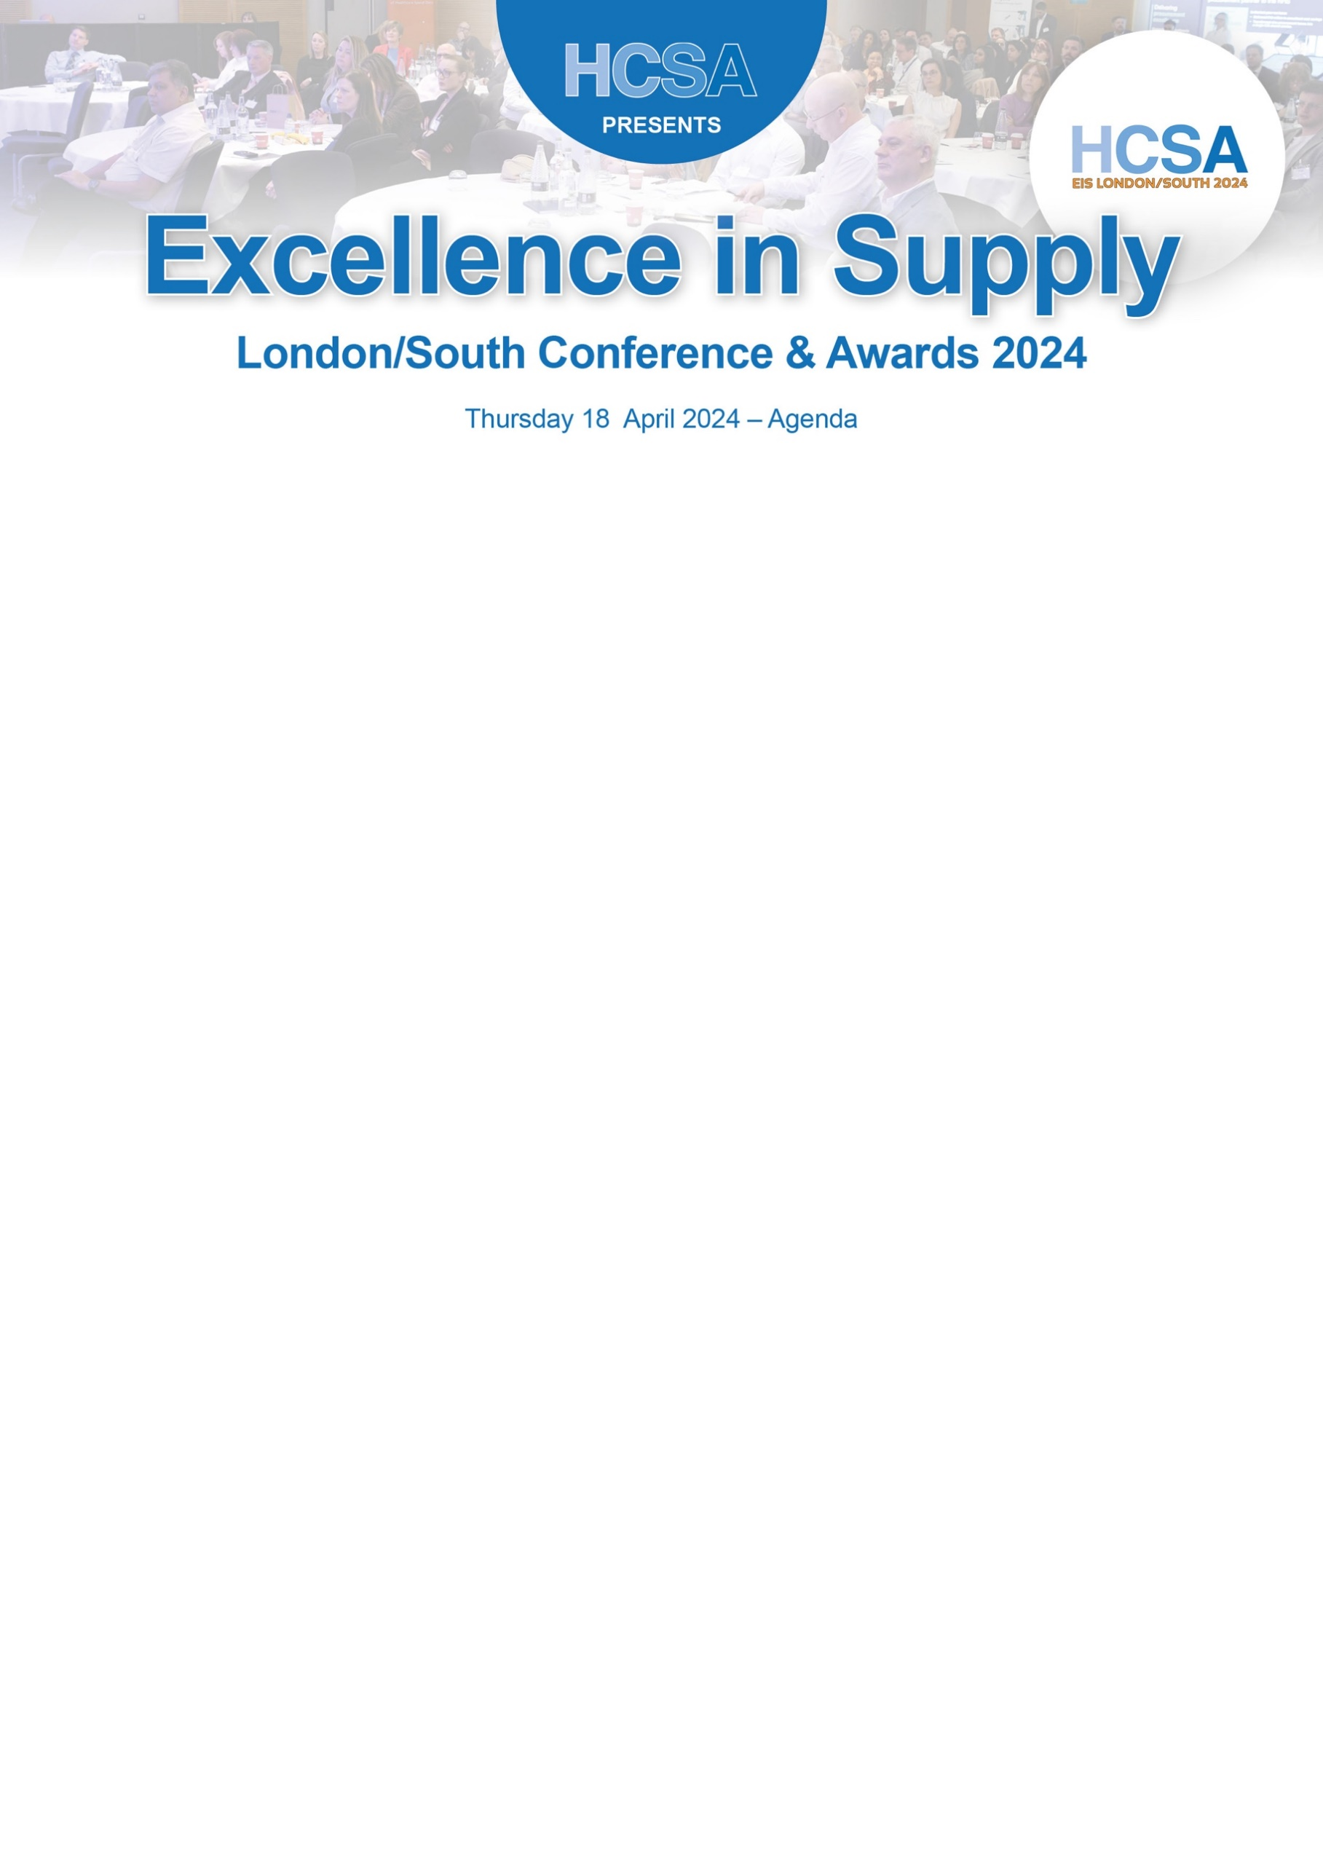

Timing | Description
8.45am – 9.30am | Registration –  Lanyards – Sponsored by GXO
9.30am – 9.35am | Our Chairman for the day – Lee Joseph
9.35am – 09.50am | Opening – Andrew Stradling  HCSA National Council Medical Director
09.50am – 10.30am | Keynote Speech – Dr Ashike Choudhury  Deputy Director of Medical Education at Medway  Human Factors, also called Ergonomics, is an evidence-based scientific discipline and profession that uses a design-driven systems approach to achieve two closely related outcomes of performance and wellbeing. It is applicable in all areas of healthcare and when analysing root causes of when things go wrong. Interaction is encouraged!
10.30am – 10.50am | Coffee Break –In Partnership with HCSA Women’s Network
10.50am – 11.25am | Janice Nelson: How to incorporate EDI in your procurement strategy.  Taking action to reduce barriers faced by minority suppliers. Learning how to promote and implement EDI in procurement policies and strategies.  Janice Nelson is a Registered Nurse, Midwife and Health Visitor and Specialist Practitioner in Public Health. With extensive public health knowledge and experience in various roles as a Public Health Programme Manager, she is passionate about change management and value-based procurement. Janice also champions and leads, Equality, Diversity and Inclusion in Procurement.  Clare Nash : It’s not easy being green.  Clare Nash has been a registered nurse for 31 years, specialising in cardiothoracic and general critical care, and is now leading on sustainable clinical procurement. She currently works as Head of Clinical Products Management for the Black Country Alliance Procurement Team working across two English Acute NHS Trusts.  Her most recently published papers include “Time to Act: what nurses can do to reduce the environmental burden of PPE” and “Is it really greener, a tool for choosing sustainable clinical products” and she is passionate about sharing the small changes nursing and healthcare staff can make to reduce the NHS carbon footprint.
11.25am – 12.15pm | Case Study 1  Absolute Interpreting and Translations  Absolute Interpreting and Translations, showcasing how to unlock 25%-35% ongoing savings on interpretation & translation services while enhancing patient experience up to 97%. Our APLS™ seamlessly integrates with EPR systems, freeing NHS staff from all booking, cancellation, confirmation and reminder hassles. Explore how it boosted patient satisfaction to 98.7%, saved £1.2m yearly, and fostered inclusivity. Join our case study presentation. | Case Study 2  Liaison  A live case study session that takes a deep dive into how NHS organisations have managed to significantly reduce agency spending, whilst increasing workforce capacity. Real life examples include how NHS Trusts across the UK have improved candidate attraction, increased staff retention and improved workforce productivity.”
12.15pm – 1.15pm | Lunch – Kindly Sponsored by Bbraun
1.15pm – 2.05pm | Case Study 1  Absolute Interpreting and Translations  Absolute Interpreting and Translations, showcasing how to unlock 25%-35% ongoing savings on interpretation & translation services while enhancing patient experience up to 97%. Our APLS™ seamlessly integrates with EPR systems, freeing NHS staff from all booking, cancellation, confirmation and reminder hassles. Explore how it boosted patient satisfaction to 98.7%, saved £1.2m yearly, and fostered inclusivity. Join our case study presentation. | Case Study 2  Liaison  A live case study session that takes a deep dive into how NHS organisations have managed to significantly reduce agency spending, whilst increasing workforce capacity. Real life examples include how NHS Trusts across the UK have improved candidate attraction, increased staff retention and improved workforce productivity.”
2.05pm – 2.50pm | Ryan Parke – The Men’s Coach  Discover how hormones, lifestyle, and goal setting influence male mental health with this engaging talk from TEDx speaker Ryan Parke. Drawing from 900+ sources and his experience coaching men, Ryan's talk unveils groundbreaking insights, offering science-based strategies to support the men you care about.
2.50pm – 3.20pm | Main Sponsor - HPCA - Jo Stanford  The Pirate Code and Ninja Stealth: Delivering Effective Change Leadership  We all have a critical role to plan in improving healthcare. In this session you will learn how to lead teams and organisations through change and creating a culture of engagement using the Pirate Code and Ninja Stealth.  Attendees will learn about neuroscience and the methods and tools to plan effective change. Attendees will come away with valuable insights and actionable takeaways to develop their ability to enhance change engagement at all levels within their organisation.
3.20pm – 3.40pm | Coffee Break – In Partnership with HCSA Women’s Network
3.40pm – 4.15pm | Andrew Daly  Procurement law update  Andrew will provide an update on the latest developments in procurement law, looking at key developments with the impending introduction of the Procurement Act 2023, as well as updates on the Provider Selection Regime since its introduction on 1/1/24.
4.15pm – 4.50pm | Liz Capp Gray  Associate Director NHS Commercial Interventions  The Strategic Framework for NHS Commercial  The Strategic Framework for NHS Commercial and how these link in with the Central Commercial Function (CCF) Core Service Offers & the Commercial Efficiencies Optimisation Programme (CEOP).  Followed by an overview of the CEOP Procurement Frameworks Workstream, highlighting the recently published list of Accredited Host Organisations, the changes to the NHS Standard Contract that underpin these accreditations, and the next phase of the programme which seeks to de-duplicate and rationalise the procurement framework landscape, by category and sub-category of spend.”
4.50pm – 5.00pm | Closing Address – Lee Joseph
Collect Room Keys and some respite before the Awards Dinner

6.30pm – 7.30pm | Pre-Dinner Drinks Reception – Main Room Bar Area  Kindly Sponsored by AdviseInc
7.30pm | Welcome Speech by Faye Robinson  (Dinner is Served – Two courses)
Awards Dinner | Wine on the table kindly sponsored Globe Locums
8.30pm | NHS Awards – Who will be our winners?
8.45pm  Mid-awards Presentation | Young lives Vs Cancer – Kim Mangelshot  When a child or young person is diagnosed with cancer, their whole world (and their family’s) can feel like it’s falling apart. Their anxieties are deep. Their education, mental health and social lives suffer. Their futures feel very uncertain.  Young Lives vs Cancer's specialist social workers provide tailored psychosocial support to children and young people with cancer, and their families.  We stop at nothing to make sure they can get the right care and support at the right time. ​​​​​​
9.15pm – 9.45pm | Dessert and Coffee
9.45pm – 10.15pm | Supplier Award Presentations – Who are our winners?
10.15pm to Midnight | Let’s Party – Late evening dance!
Midnight | Bar closes at midnight  Post Dinner Drinks are available to residents only in the hotel bar

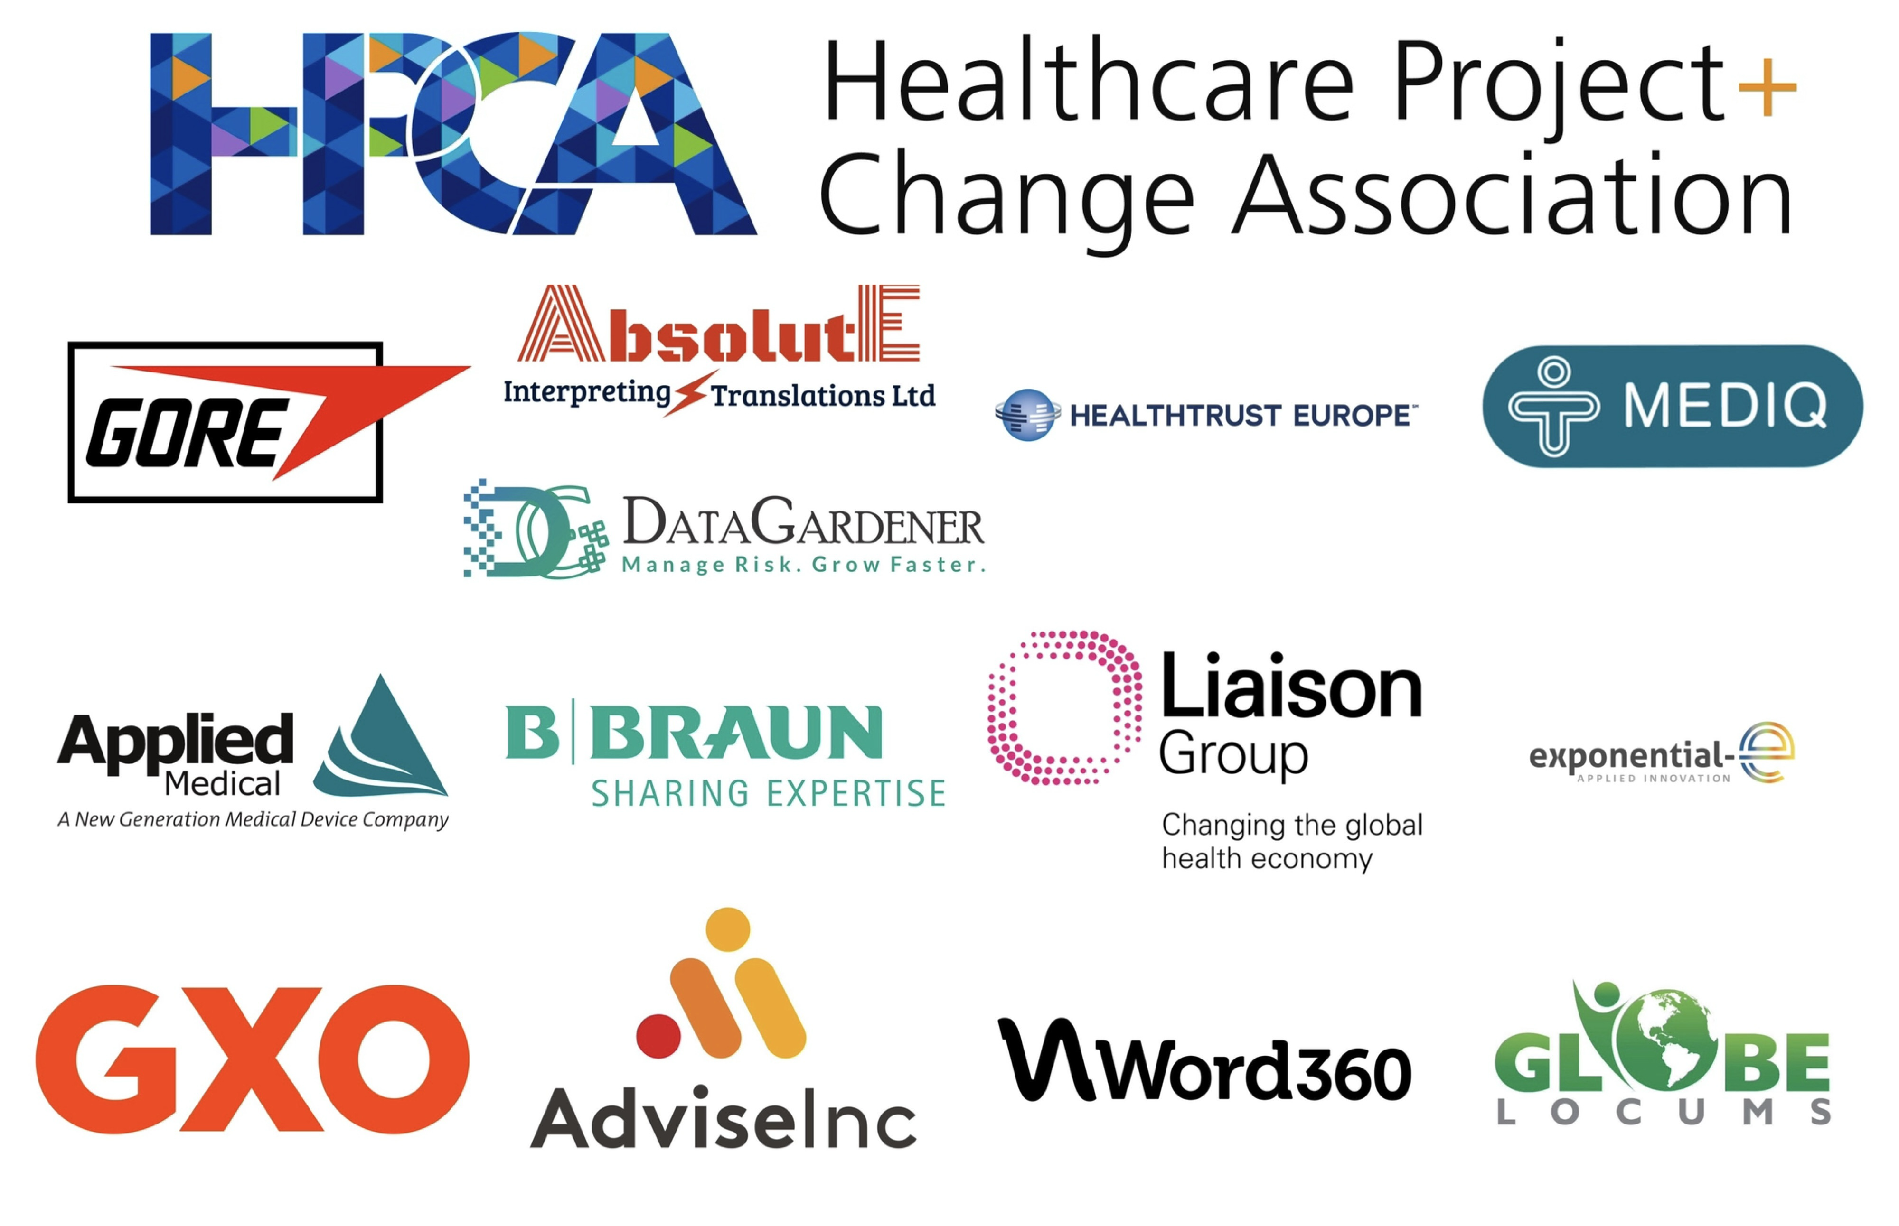
THANK YOU TO ALL OUR SPONSORS

